Names: Faiqa Malik

Muhammad Ali Butt,

Umamah Hussain

Class: BCS – 1A

Roll #: 21L-1865, 21L-7646, 21L-1858

**Ict lab activity**

**Self driving cars.**

**Introduction**:

A self-driving car is a car that is able to travel from one point to another without any human intervention, meaning it is able to reach its destination without the supervision of a driver. This is why such cars are also referred to as driverless cars. They “understand” their environment through hardware sensors and this data is interpreted by a computer. This computer then generates instructions used to guide the car to its destination safely. The leading organization in this technology sector is currently known as “Tesla”.

The idea of self-driving cars seems futuristic and far away, society is actually very close to seeing them on the road. Taking the wheel away from humans and putting them into the hands of computers and artificial intelligence will obviously change travel forever. As a result, there are many questions that need to be addressed before people feel comfortable trusting automated vehicles. What type of technology will be necessary to ensure self-driving cars operate safely and think like humans? Will they really make roads safer? Will people buy them? How will they affect traffic?

Currently self-driving cars are being trained on the streets with human driven cars, which I think is a mistake. After all, ultimate goal of self-driving cars is to be alone on the road. If that is the case, then such cars would need to train in an environment, where only automated vehicles are present. This environment would obviously also include pedestrians, bicycles and all kinds of motorcycles. As much as bicycles and motorcycles can be equipped with sensors, pedestrians would need to be watched by AI controlled cameras. In order to truly introduce autonomous vehicles, a company trying to do that should basically enter into agreement with a relatively small town, village or few blocks in the city. That area would then be closed completely to any human-driven vehicles, with exception of bicycles and motorcycles, where each would be equipped with GPS sensors. Such sensors would send data such as direction, speed and position to central brain controlling whole area. Whoever coming into that part of town in human-driven vehicle would need to leave it and switch to automated car coming to pick him up on demand.

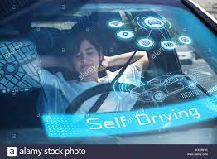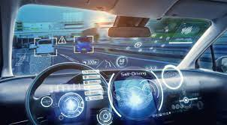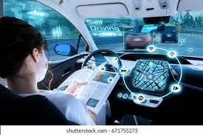

**Techniques for how to runs car autonomously:**

Of course autonomous cars would communicate with each other, and also with mentioned “brain”. In order to watch over pedestrians, an AI driven camera system covering the test area would be used to predict speed, direction and position of any human on the street, especially near street crossings. That in order to be able to alert cars of potential danger – cars then would slow down or stop; if there would be a chance of someone running or coming on the street suddenly. I envision cars analyzing data only from certain area around them; data which would be irrelevant would be ignored. Such solution removes completely pointless ethical decisions such as “should the automatic car choose to hit a child on a bicycle or a bus full of nuns”. In controlled environment, bus would “speak” to the car and both would stop or slow down early enough to let the kid on a bike safely pass.

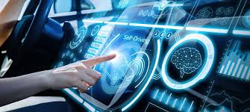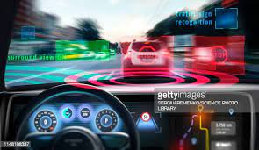

* **Advantages of self driving cars:**

1. No accidents due to emotional behavior
2. Fuel savings
3. Less air pollution
4. Car theft reduction
5. No risk of drunk driving

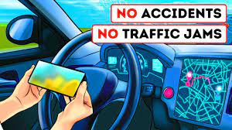

* **Disadvantages of self-driving cars:**

1. Insurance problems
2. Low level of acceptance of the public
3. Danger of hacking attacks
4. High purchase price
5. Fewer job opportunities for others



